 **Methods 11 Test 1 2018**

**Quadratic and Linear Functions**

**Total Marks: 59 Time Allowed: 60 minutes**

**Name: _______________________**

**Resource Free**

**ALL** working must be shown for full marks.

**1.** **[4, 4, 3, 3 = 14 marks]**

Solve the following:

a) $\frac{4}{4-x}= \frac{4}{x+2}+1$ b) $x^{2}+4x-3=0$

c) $6x^{2}-x-2=0$ d) solve by completing the square

$x^{2}+4x-6=0$

**2. [2, 2, 2, 2 = 8 marks]**

Find the discriminant of each quadratic equation and state the number of real roots it has.

a) $x^{2}-x-4=0$ b) $2x^{2 }+3x+6=0$

c) $x^{2 }+6x+9=0$ d) $-2x^{2}+8x-2=0$

**3.** **[3, 2 = 5 marks]**

The line with equation 7x + 5y = 70 intersects the x-axis and y-axis at A and B respectively.

a) Find the coordinates on the mid-point AB.

b) Find the distance between A and B. Leave answer in exact form.

**4. [3, 2, 2 = 7 marks]**

a) What is the equation of the line passing through the point (-5, 3) and is perpendicular to

2y = 10x – 6?

b) Write the equation of the line that passes through the point (-2, 4) and is parallel to the equation y = 3x + 2.

c) A line passes through the point with coordinates (1, 2) and has a gradient of 2. If it passes through the point with coordinates (5, k) find the value of k.

**5. [6 marks]**

In the triangle ABC, A has co-ordiantes (-6, -3) while B has co-ordinates (k, 5) and C has co-ordinates (8, 2). Find the value of k if angle ABC is a right angle.

**6.** **[2, 2, 2 = 6 marks]**

Define each of the following as a function, or a relation, giving a reason for your choice.

a) b) c)

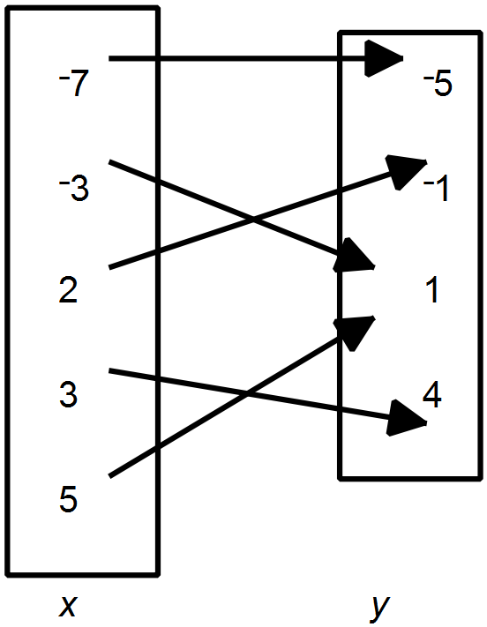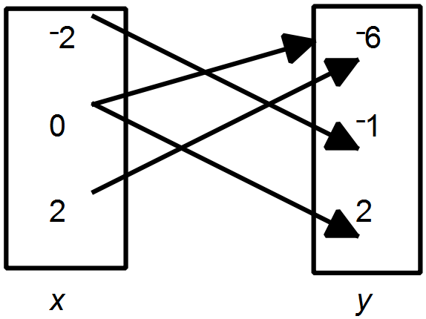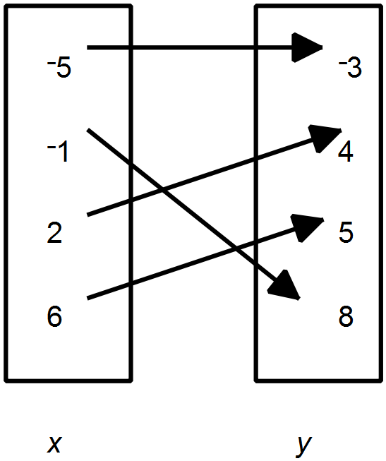

**7. [3, 5 = 8 marks]**

Determine the equation for the following.

a)

|  |  |  |  |  |  |  |
| --- | --- | --- | --- | --- | --- | --- |
| x | 0 | 1 | 2 | 3 | 4 | 5 |
| y | -2 | 7 | 24 | 49 | 82 | 123 |

b)

|  |  |  |  |  |  |  |
| --- | --- | --- | --- | --- | --- | --- |
| x | 2 | 3 | 4 | 5 | 6 | 7 |
| y | 19 | 32 | 49 | 70 | 95 | 124 |

**8.** **[1, 1, 1, 2 = 5 marks]**

The value of a photocopier *t*  years after purchase is given by V = 9000 – 900*t* dollars.

a) Find V when *t* = 4.

b) Find *t* when V is 3600.

c) Find the orginial purchase price of the photocopier.

d) For what values of *t* is it reasonable to use this function? Give an explanation.